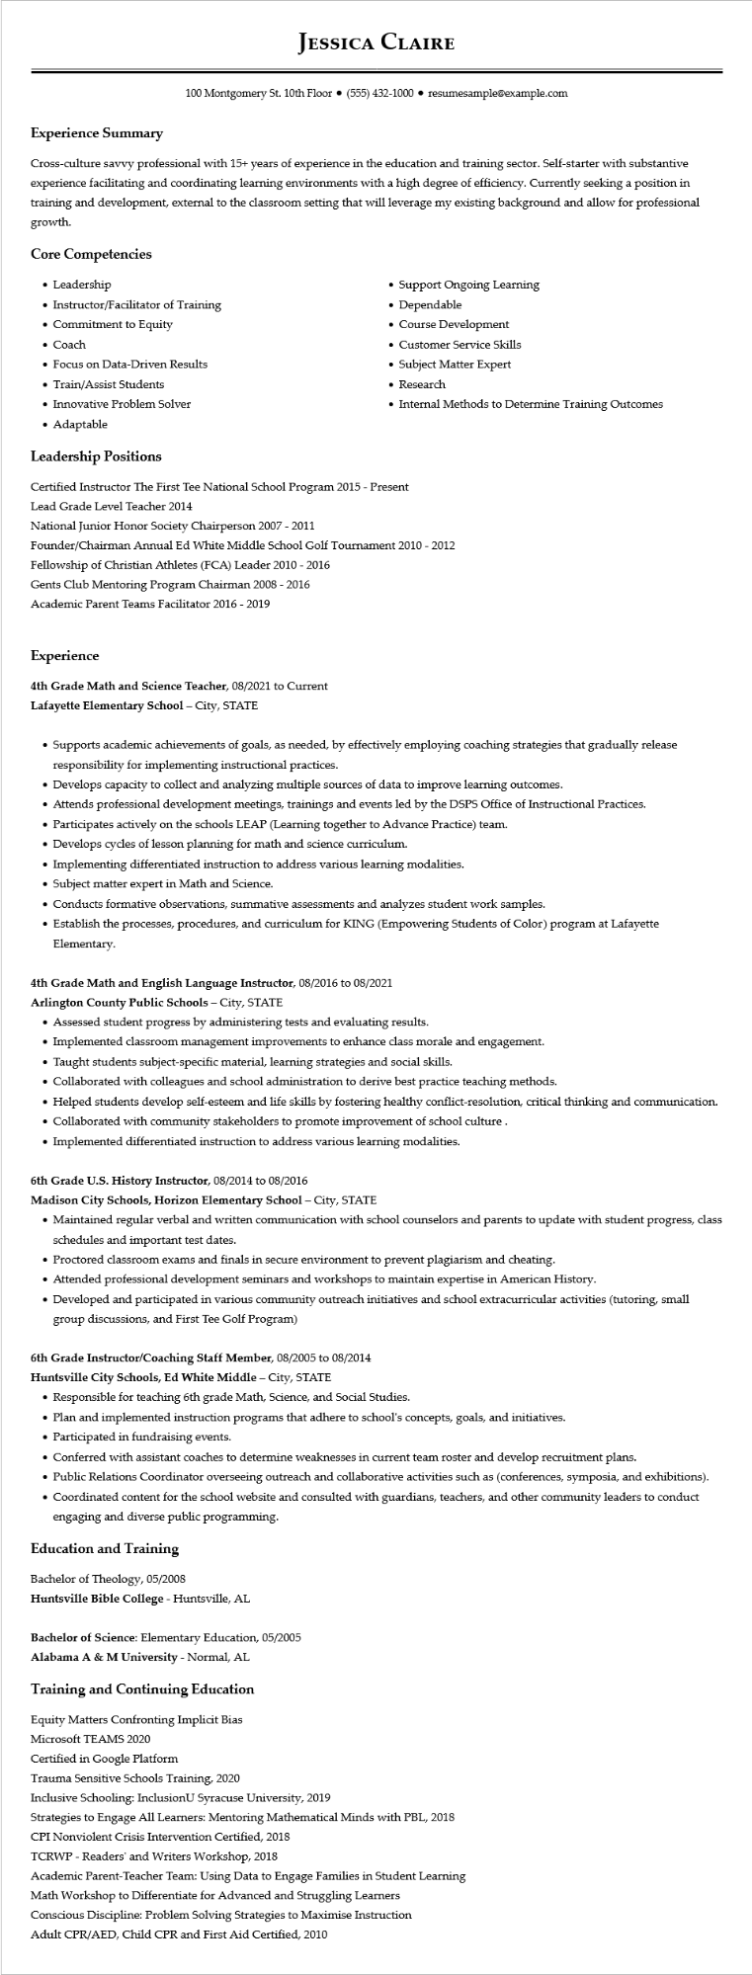
Experience Summary
JESSICA CLAIRE
100 Montgomery St. 10th Floor⚫ (555) 432-1000⚫ resumesample@example.com
Cross-culture savvy professional with 15+ years of experience in the education and training sector. Self-starter with substantive experience facilitating and coordinating learning environments with a high degree of efficiency. Currently seeking a position in training and development, external to the classroom setting that will leverage my existing background and allow for professional growth.
Core Competencies
• Leadership
• Instructor/Facilitator of Training
• Commitment to Equity
• Coach
• Focus on Data-Driven Results
• Train/Assist Students
• Innovative Problem Solver
• Adaptable
Leadership Positions
• Support Ongoing Learning
•
Dependable
• Course Development
• Customer Service Skills
• Subject Matter Expert
• Research
• Internal Methods to Determine Training Outcomes
Certified Instructor The First Tee National School Program 2015 - Present
Lead Grade Level Teacher 2014
National Junior Honor Society Chairperson 2007 - 2011
Founder/Chairman Annual Ed White Middle School Golf Tournament 2010 - 2012
Fellowship of Christian Athletes (FCA) Leader 2010 - 2016
Gents Club Mentoring Program Chairman 2008 - 2016
Academic Parent Teams Facilitator 2016 - 2019
Experience
4th Grade Math and Science Teacher, 08/2021 to Current
Lafayette Elementary School - City, STATE
• Supports academic achievements of goals, as needed, by effectively employing coaching strategies that gradually release responsibility for implementing instructional practices.
• Develops capacity to collect and analyzing multiple sources of data to improve learning outcomes.
• Attends professional development meetings, trainings and events led by the DSPS Office of Instructional Practices.
• Participates actively on the schools LEAP (Learning together to Advance Practice) team.
• Develops cycles of lesson planning for math and science curriculum.
• Implementing differentiated instruction to address various learning modalities.
• Subject matter expert in Math and Science.
• Conducts formative observations, summative assessments and analyzes student work samples.
• Establish the processes, procedures, and curriculum for KING (Empowering Students of Color) program at Lafayette Elementary.
4th Grade Math and English Language Instructor, 08/2016 to 08/2021
Arlington County Public Schools - City, STATE
• Assessed student progress by administering tests and evaluating results.
• Implemented classroom management improvements to enhance class morale and engagement.
•
Taught students subject-specific material, learning strategies and social skills.
• Collaborated with colleagues and school administration to derive best practice teaching methods.
• Helped students develop self-esteem and life skills by fostering healthy conflict-resolution, critical thinking and communication.
• Collaborated with community stakeholders to promote improvement of school culture.
• Implemented differentiated instruction to address various learning modalities.
6th Grade U.S. History Instructor, 08/2014 to 08/2016
Madison City Schools, Horizon Elementary School - City, STATE
• Maintained regular verbal and written communication with school counselors and parents to update with student progress, class schedules and important test dates.
• Proctored classroom exams and finals in secure environment to prevent plagiarism and cheating.
• Attended professional development seminars and workshops to maintain expertise in American History.
• Developed and participated in various community outreach initiatives and school extracurricular activities (tutoring, small group discussions, and First Tee Golf Program)
6th Grade Instructor/Coaching Staff Member, 08/2005 to 08/2014
Huntsville City Schools, Ed White Middle - City, STATE
• Responsible for teaching 6th grade Math, Science, and Social Studies.
• Plan and implemented instruction programs that adhere to school's concepts, goals, and initiatives.
• Participated in fundraising events.
• Conferred with assistant coaches to determine weaknesses in current team roster and develop recruitment plans.
• Public Relations Coordinator overseeing outreach and collaborative activities such as (conferences, symposia, and exhibitions).
• Coordinated content for the school website and consulted with guardians, teachers, and other community leaders to conduct engaging and diverse public programming.
Education and Training
Bachelor of Theology, 05/2008
Huntsville Bible College - Huntsville, AL
Bachelor of Science: Elementary Education, 05/2005
Alabama A & M University - Normal, AL
Training and Continuing Education
Equity Matters Confronting Implicit Bias
Microsoft TEAMS 2020
Certified in Google Platform
Trauma Sensitive Schools Training, 2020
Inclusive Schooling: InclusionU Syracuse University, 2019
Strategies to Engage All Learners: Mentoring Mathematical Minds with PBL, 2018
CPI Nonviolent Crisis Intervention Certified, 2018
TCRWP - Readers' and Writers Workshop, 2018
Academic Parent-Teacher Team: Using Data to Engage Families in Student Learning
Math Workshop to Differentiate for Advanced and Struggling Learners Conscious Discipline: Problem Solving Strategies to Maximise Instruction Adult CPR/AED, Child CPR and First Aid Certified, 2010

